TASK EXPLAINATION

RSI (Relative Strength Index)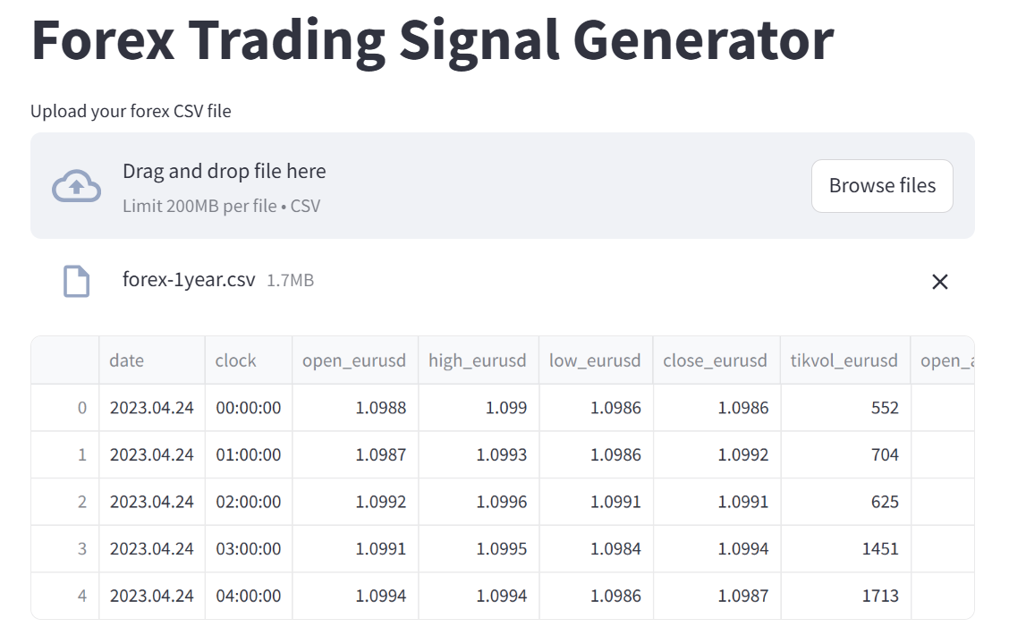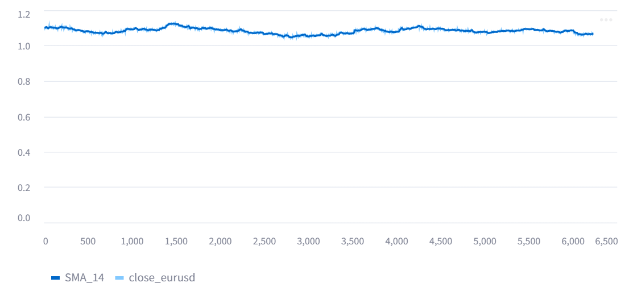

* currency pair (EUR/USD) is **stable**, with little trend.
* SMA_14 (average of 14 previous closes) is closely hugging the actual price.
* Not much fluctuation

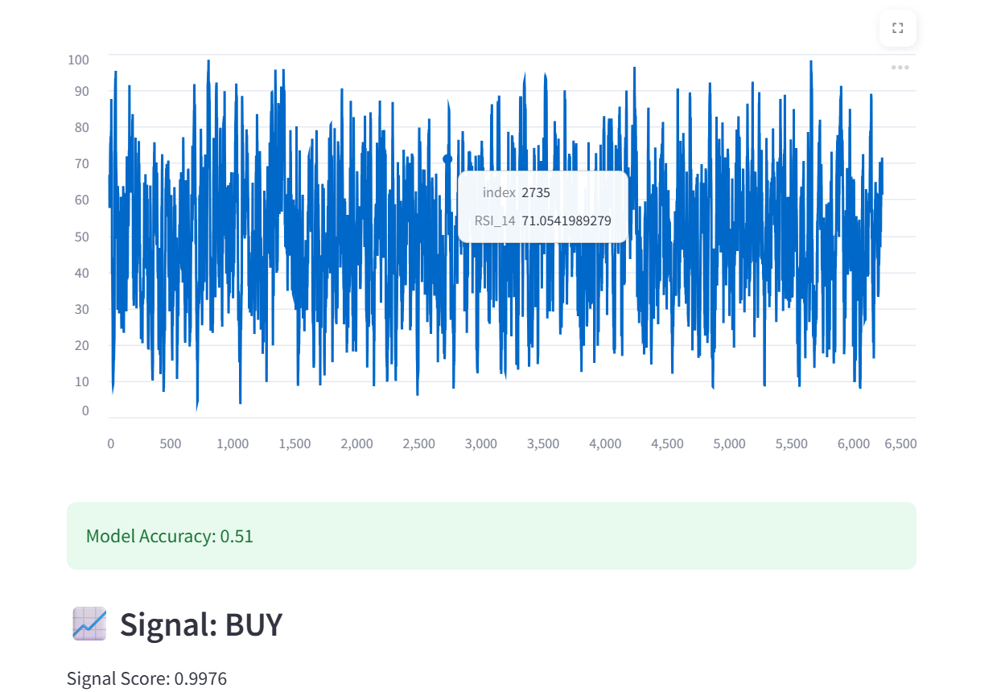

**Here accuracy is less only 0.51 which is little more than 50 percent ie slightly more than random probablility.**

**Signal Score = 0.9976 → High confidence**